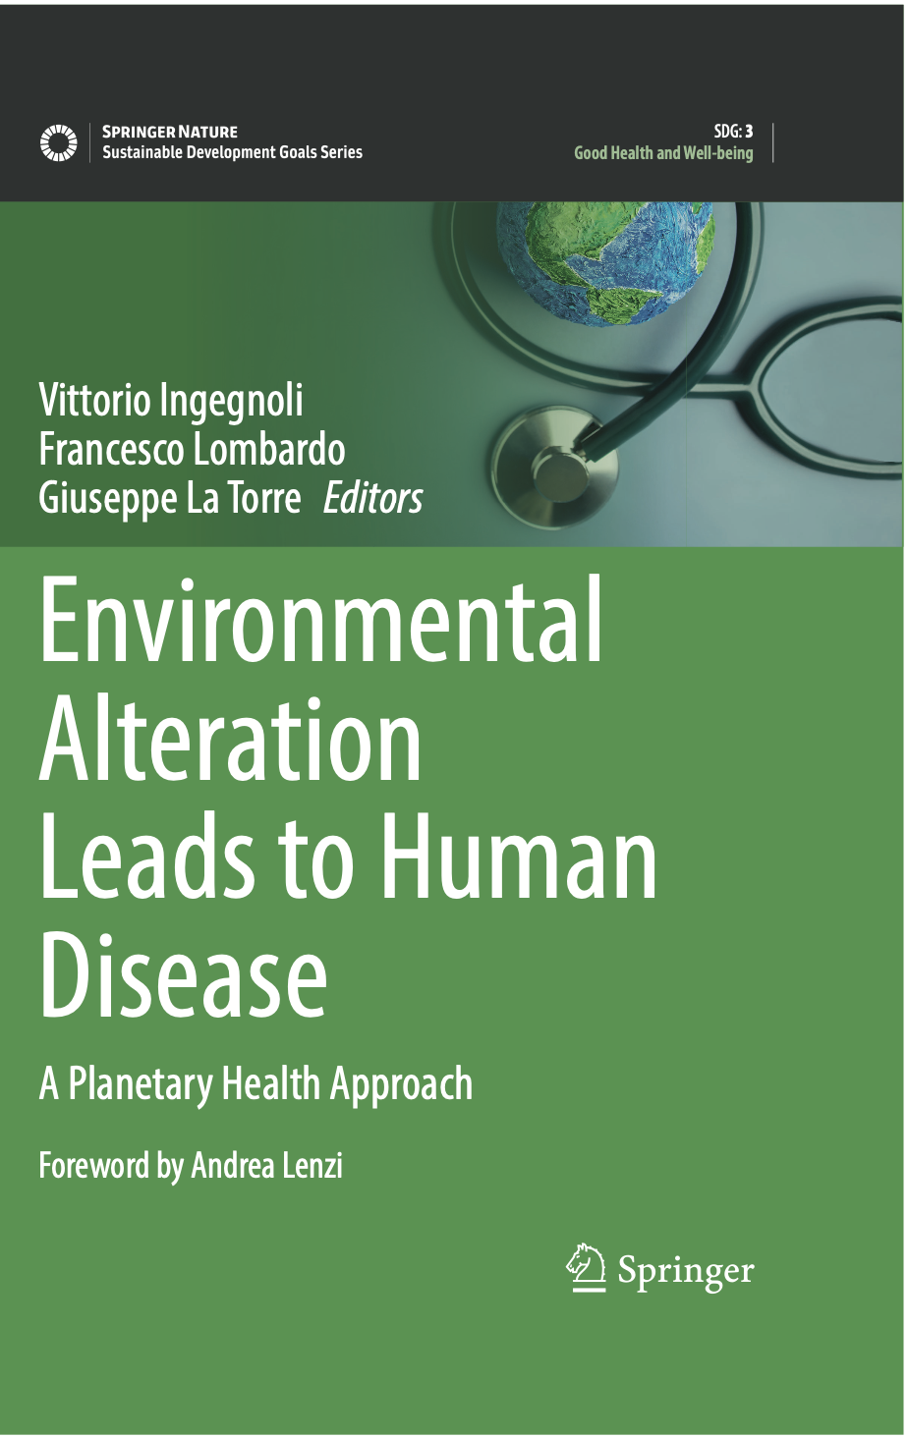 | © 2022  Environmental Alteration Leads to Human Disease  A Planetary Health Approach  Editors: Ingegnoli, Vittorio, Lombardo, Francesco, La Torre, Giuseppe (Eds.)  - Foreword by Andrea Lenzi, Rome Sapienza University  - Explores the effects of ecological alterations on human health  Public Health  Sustainable Development Goals Series
This book aims to explore the impact of human alterations of Earth’s ecological systems on human health. Human activities are producing fundamental biophysical changes faster than ever before in the history of our species, which are accompanied by dangerous health effects. Drawing on advanced ecological principles, the book demonstrates the importance of using systemic medicine to study the effects of ecological alterations on human health.
Planetary Health is an interdisciplinary field, but first of all it must be systemic, and it needs a preferential relationship between Ecology and Medicine. This relation is to be upgrading, because today both ecology and medicine pursue few systemic characters and few correct interrelations. We need to refer to new principles and methods sustained by the most advanced fields, as Landscape Bionomics and Systemic Medicine. Thus, we will be able to better discover environmental syndromes and their consequences on human health. Environmental transformations proposed by PHA (from biodiversity shifts to climate change) do not consider bionomic dysfunctions which can menace human health. On the contrary, finding advanced diagnostic criteria in landscape syndromes can strongly help to find the effects on human well-being. The passage from sick care to health care can’t avoid the mentioned upgrading.

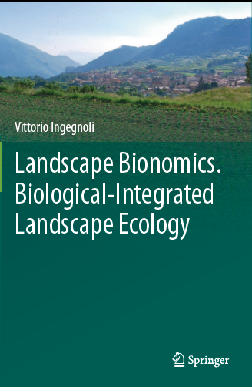 | © 2015  Landscape Bionomics, Biological-Integrated Landscape Ecology  Author: Ingegnoli, Vittorio  Foreword by Sandro Pignatti, Roma, Sapienza University
"Landscape Bionomics,” or “Bio-integrated Landscape Ecology,” radically transforms the main principles of traditional Landscape Ecology by recognizing the landscape as a living entity rather than merely the spatial distribution of species and communities on the territory, often analysed in separate themes (water, species, pollution, etc.). To be more exact, the landscape is identified as the "life organization integrating a set of plants, animals, and human communities and its system of natural, semi-natural, and human cultural ecosystems in a certain spatial configuration." This new perspective inevitably leads to significant changes in how to assess and manage the environment.
This book represents the culmination of an endeavor begun by the author, with the support of Richard Forman and Zev Naveh, more than a dozen years ago. It builds on the author’s previous successful publication, Landscape Ecology, A Widening Foundation, by addressing a range of additional topics and discussing the new theoretical and methodological concepts that have emerged during the past decade of research. Particular attention is paid to the fact that interventions in the landscape can be made with the best intentions yet cause serious damage! Against this background, the author explains the need to study "landscape units" by applying methods comparable to those used in clinical diagnosis – hence ecologists can be viewed as the “physicians” of ecological systems.

